SUPPLEMENTARY ONLINE MATERIALS
for
More Diverse, More Skeptical? How Changes in Class-based Network Diversity Shape Public Support for Commodified Welfare Services: Longitudinal Evidence from Chile

Social Forces

Version: November 2025.

Supplementary materials
Class-based network diversity index
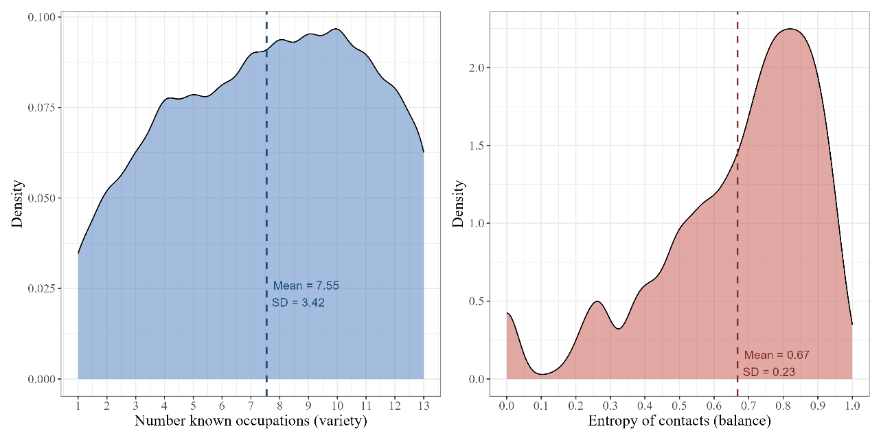
Figure S1: Components of the class-based network diversity index
To assess whether the two indicators of network diversity capture a common latent dimension, a Principal Components Analysis (PCA) was conducted using the “psych” package in R (Revelle, 2025). The analysis included the entropy and the total number of known occupations as observed variables. A single-component solution with varimax rotation was extracted. The results indicated that a one-component structure provided a good representation of the data. Both indicators loaded adequately on the first principal component (0.98 for variety, 0.98 for entropy ), with communalities of 0.97, showing that nearly all variance in each variable is explained by the common factor. The extracted component accounted for 97% of the total variance (SS loading = 1.93), and the root mean square of residuals (RMSR = 0.03) indicated a good model fit. The mean item complexity of 1 further confirmed that each variable is adequately associated with the same latent dimension.

Table S1: occupations included in the position generator
Occupation | ISEI-08
Doctor | 88
Attorney | 85
University professor | 77
Manager of a large firm | 70
Accountant | 60
Secretary | 53
Shop assistant | 43
Preschool teacher | 43
Waiter | 34
Car mechanic | 34
Taxi driver | 30
Street vendor | 29
Office cleaner | 16

Table S2: Descriptive statistics for study variables
Variable | N | Mean | SD | Min | Max
Market justice preference | 6562 | 2 | 0.87 | 1 | 5
Entropy | 6562 | 0.67 | 0.23 | 0 | 1
Extensivity | 6562 | 7.5 | 3.4 | 1 | 13
Class-based network diversity | 6562 | 0.00 | 1 | -2.4 | 1.5
Occupational Status (ISEI) | 6562 | 27 | 19 | 10 | 88
Network status | 6562 | 48 | 10 | 16 | 88
Network size | 6562 | 28 | 25 | 1 | 197
Age | 6562 | 49 | 15 | 18 | 90
Sex | 6562
... Man | 2493 | 38%
... Woman | 4069 | 62%

Supplementary analysis
Intragenerational social mobility trajectories
To construct the trajectories of intragenerational mobility or simply “mobility profiles”, I used four categories for individuals’ occupational status: low, middle, high, and NEET. The procedure consists of two stages. First, individuals are categorized based on their first and last observed positions to identify profiles of mobility and stability. Second, to ensure a more robust classification of stability, I implemented the Class Mode Approach (Ares & Van Ditmars, 2025; Helgason & Rehm, 2024). Here, those who participated in the panel for three to four waves and remained in the same position for at least 75% of the time are classified as stable.
Table S2: Occupational socioeconomic status and intragenerational social mobility trajectories
Mobility | Freq. | % | Mobility | Freq. | %
Downward (Any to NEET) | 688 | 10.48 | Downward | 941 | 14.34
Downward (H to L) | 75 | 1.14 | Downward | 941 | 14.34
Downward (H to M) | 88 | 1.34 | Downward | 941 | 14.34
Downward (M to L) | 90 | 1.37 | Downward | 941 | 14.34
Stable: high | 794 | 12.10 | Stable: high | 794 | 12.10
Stable: low | 760 | 11.58 | Stable: low | 760 | 11.58
Stable: middle | 633 | 9.65 | Stable: middle | 633 | 9.65
Stable: NEET | 2095 | 31.93 | Stable: NEET | 2095 | 31.93
Upward (L to H) | 119 | 1.81 | Upward | 1339 | 20.41
Upward (L to M) | 399 | 6.08 | Upward | 1339 | 20.41
Upward (M to H) | 307 | 4.68 | Upward | 1339 | 20.41
Upward (NEET to Any) | 514 | 7.83 | Upward | 1339 | 20.41

Methods
To examine whether changes in network diversity are associated with market justice while accounting for mobility trajectories in the model specification, I employed a between-within (hybrid) multilevel regression model (Schmidt-Catran, 2016; Singer & Willett, 2009). This model includes two levels: individuals (j) and observations within individuals (i), with repeated measurements nested within individuals.
For this analysis, I focused on three key variables: mobility trajectories, network diversity (both individual-mean and demeaned). This approach allows for the estimation of both between (BE) and within (WE) effects of network diversity while incorporating mobility trajectories. Including both terms in the regression equation yields a hybrid model, which simultaneously estimates within- and between-unit effects. The coefficient vector for WE captures the within-individual effects of the variables, while the coefficient vector for BE represents the between-individual effects.
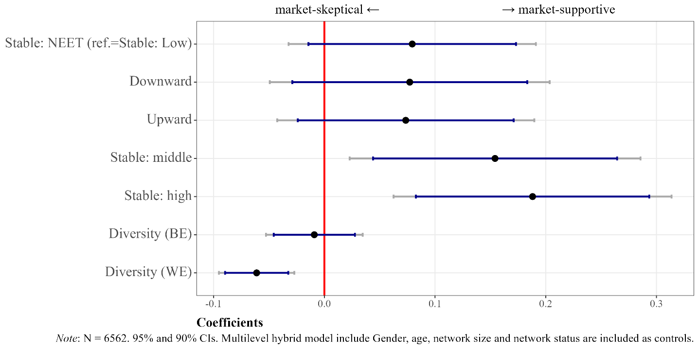
Figure S2: Multilevel within-between model for intragenerational occupational mobility, network diversity, and market justice preferences.

References
Ares, M., & Van Ditmars, M. M. (2025). A life course approach to political preference formation across social classes. West European Politics, 48(4), 951–976. https://doi.org/10.1080/01402382.2024.2415845
Helgason, A. F., & Rehm, P. (2024). Class experiences and the long-term evolution of economic values. Social Forces, soae135. https://doi.org/10.1093/sf/soae135
Revelle, W. (2025). psych: Procedures for psychological, psychometric, and personality research [Manual]. Northwestern University. https://CRAN.R-project.org/package=psych
Schmidt-Catran, A. W. (2016). Economic inequality and public demand for redistribution: Combining cross-sectional and longitudinal evidence. Socio-Economic Review, 14(1), 119–140. https://doi.org/10.1093/ser/mwu030
Singer, J. D., & Willett, J. B. (2009). Applied longitudinal data analysis: Modeling change and event occurence. Oxford University Press, Incorporated.

